Lab Assignment 3.4

Task Description #1: Zero-Shot Prompt
Without giving an example, write a single comment prompt asking GitHub Copilot to generate a Python function to print the first N Fibonacci numbers.

Prompt:
Generate a Python function to print the first N Fibonacci numbers.

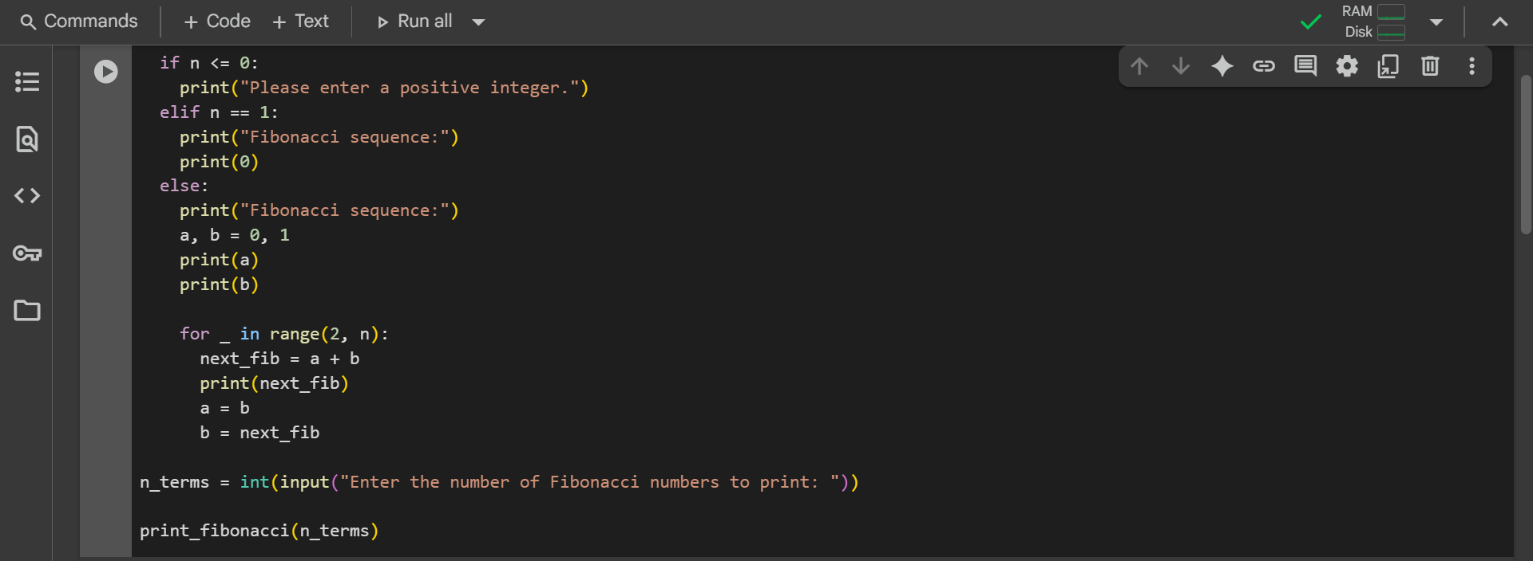
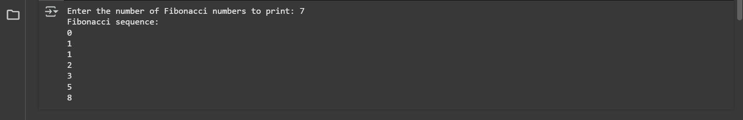

Task Description #2: One-shot Prompt
• Write a comment prompt to reverse a list and provide one example below the comment to guide Copilot.

Prompt:
Generate a python function to reverse a list using slicing, with dynamic inputs of size and values of list
Example: input [1, 2, 3] output [3,2,1]
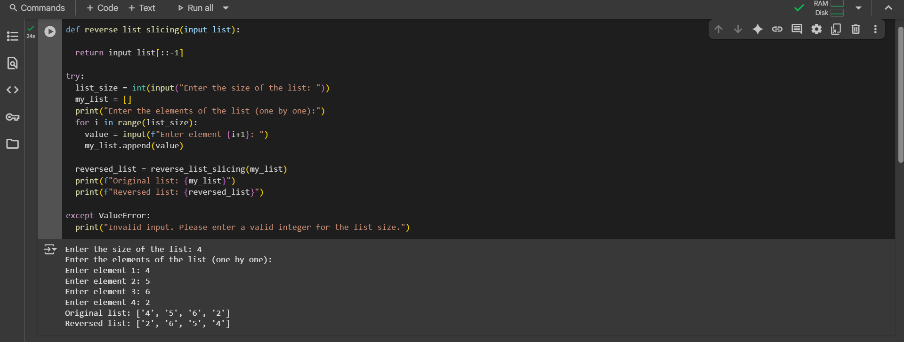

Task Description #3: Few-Shot Prompt
• Write a comment with 2–3 examples to help Copilot understand how to check if a string starts with a capital letter and ends with a period.

Prompt:
Write a python function is_valid() to check whether a string begins with Capital letter and end with a period like:
Hello, my name is Google. is True
Hello, my name is Google is False
hello, Bye is False

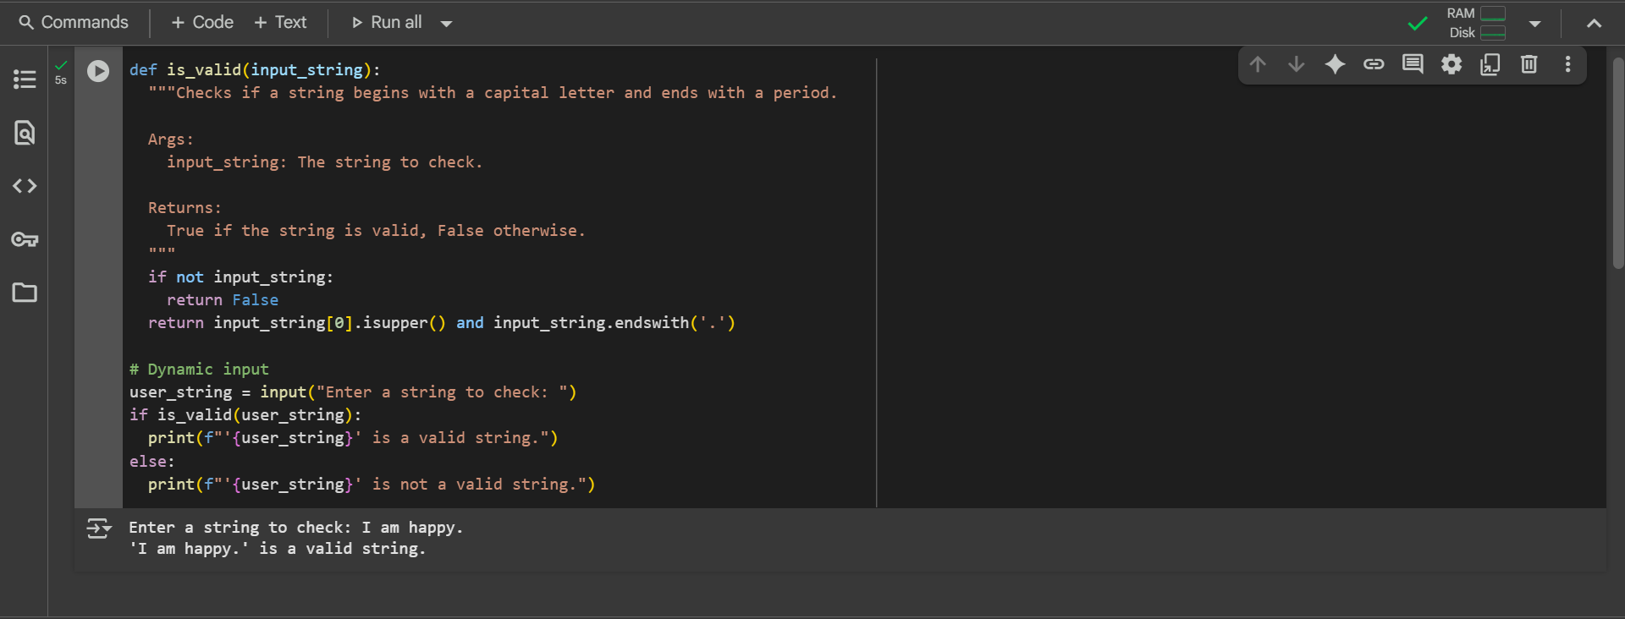

Task Description #4: Zero-shot vs Few-shot Prompt
- First, prompt Copilot to write an email validation function using zero-shot (just the task in comment).
- Then, rewrite the prompt using few-shot examples.

Prompt:
ZERO-SHOT: Write a simple python function email validator with dynamic input
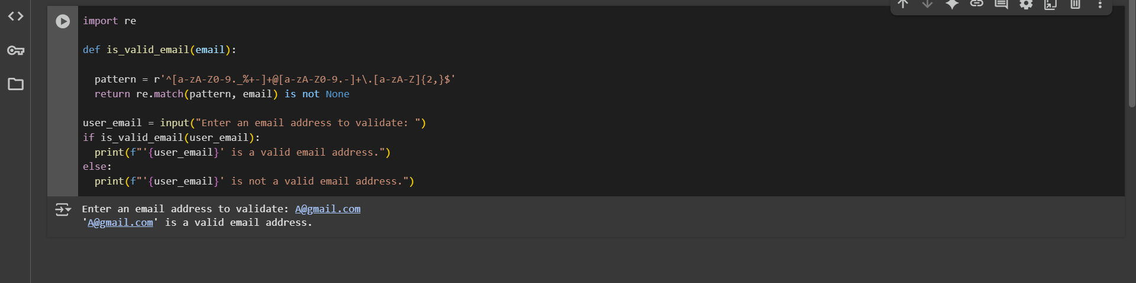

FEW-SHOT: Write a function that checks if an email contains one '@' and ends with a valid domain like .com, .org, or .net.
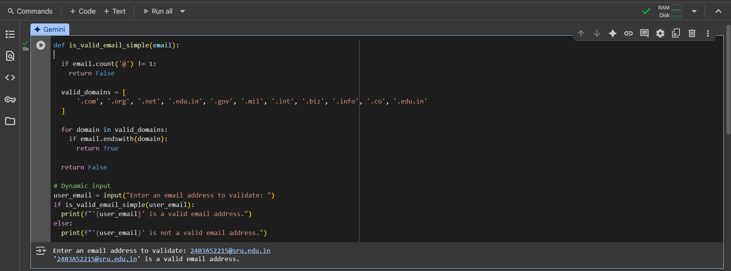

Task Description #5:
Experiment with 2 different prompt styles to generate a function that returns the sum of digits of a number.
Style 1: Generic task prompt
Style 2: Task + Input/Output example
sum_of_digits() function

Prompt 1: Generic
Generate a function that returns the sum of digits of a number.
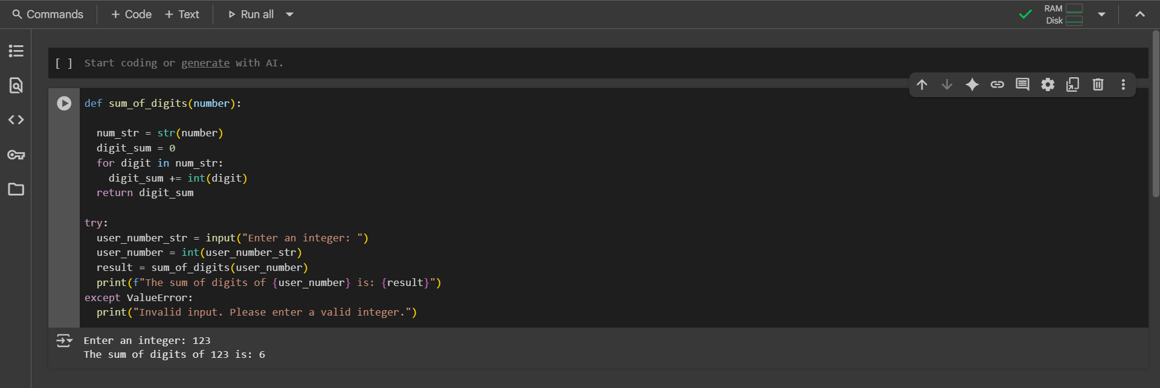
Prompt 2: Task + Input / Output
Generate a python function which takes the input from the user as integers and finds the sum of all the digits in it and then prints it out
